

# April 2, 2025

The State Coordinator

NYSC Secretariat

2, Abakaliki Road

GRA Enugu Enugu State.

**RE: CLEARANCE FOR THE MONTH OF APRIL 2025 – APATA MIRACLE PETER**

This is to certify that **Apata Miracle Peter** with State Code **EN/24C/0005** and Call up number **NYSC/FUA/2024/302840**, a corp member posted to our Company has satisfactorily performed his duties for the month of March 2025 and wish to recommend him for the month of April 2025.



Kindly accord him the necessary assistance.

Thank you.

Yours faithfully,

# For: African Pits and Quarries Limited

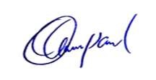

**Paul Ocheke**

**HEAD OF PEOPLE AND CULTURE**